College Bytes, LLC.

**Class Bytes**

**System User Manual**

Table of Contents

Introduction 3

Getting Started 4

Creating Your Initial Profile 5

Signing in for the First Time 6

Dashboard Page 7

Add New Class Page 8

Add New Instructor Page 9

Add New Obligation Page 10

Add New Student Contact Page 11

Class Detail Page 12

Edit Class Page 13

Edit Instructor Information Page 14

Edit Obligations Page 15

Edit Student Contacts Page 16

Support 17

# Introduction

The Class Bytes System from College Bytes, LLC is a dynamic scheduling and information system designed specifically for use by students in a collegiate setting. With the Class Bytes System, you can manage an unlimited number of classes, instructors, assignments, and grades with ease, and be able to access, modify, view, or delete any of their class-related information from anywhere that you have access to an internet connection.

Specific tasks that can be accomplished with the Class Bytes System include:

* Management and viewing of your class schedules
* Management and viewing of your instructor contact information
* Management and viewing of your student contact information on a per class basis
* Management and viewing of your assignments, tests, and labs on a per class basis
* Entering and viewing of all your grades associated with your class
* Calculation of class average grades based on entered grades and weighting schemes
* Viewing alerts of your assignments that are coming due

The Class Bytes System is a web-based information system that runs on a subscription model. A one-time subscription fee of $6.95 affords you system access for life, including any and all upgrades to the system and all future versions.

Ready to get started? So are we!

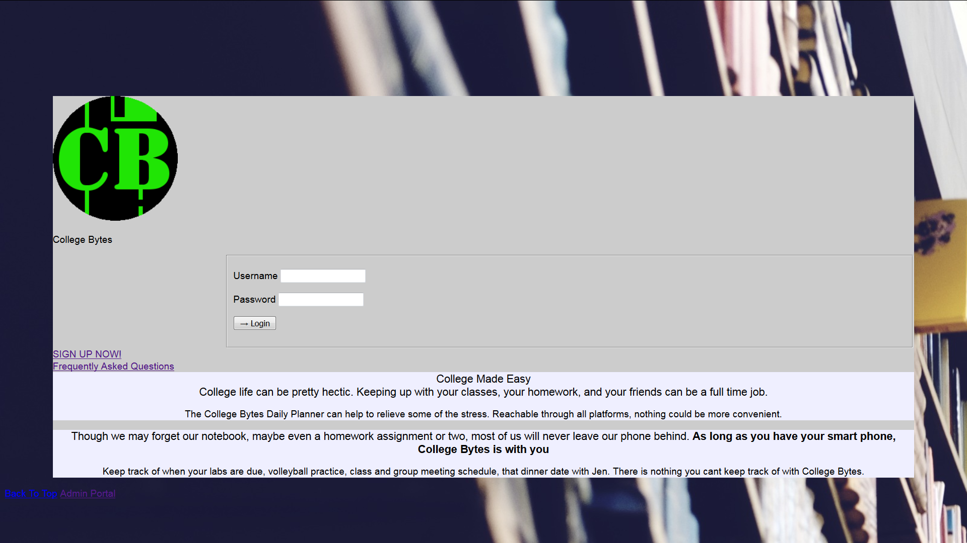

# Getting Started

Getting started with the Class Bytes System is easy. In any device with an internet connection, open up your favorite internet browser and go to <http://192.188.202.2/cis222/College_Bytes/index.php> <<<website address subject to change on final release>>>. From there, you can either click on “Learn More” to read more about what the Class Bytes System can do for you, or you can click on the “Online Help” to view this guide in a handy navigable web format, or you can just dive right in and click on “SIGN UP NOW”.

Upon clicking on “Sign Up Now”, you will be directed to our payment page. After filling out all of the requisite information and clicking the “Submit” button, your $6.95 payment will be processed. If your payment is declined, you will be able to re-enter your information using a different payment method. Remember, you will only be charged the low $6.95 fee once for access to the system for LIFE!

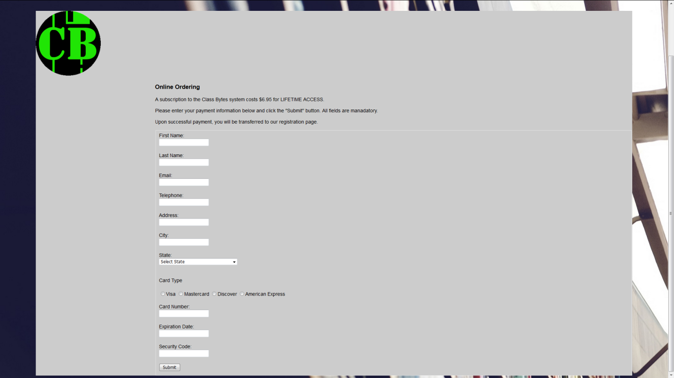

## Creating Your Initial Profile

Once your payment has been accepted, you will be forwarded to our Account Registration page, where you will be asked for your name, email address, and a password for access to the system. Your password must be at least four characters, but we suggest that you choose a strong alpha-numeric password. Your email address will become your username. Please remember your username and password. Not to worry, we will never divulge your email address or name to third parties!

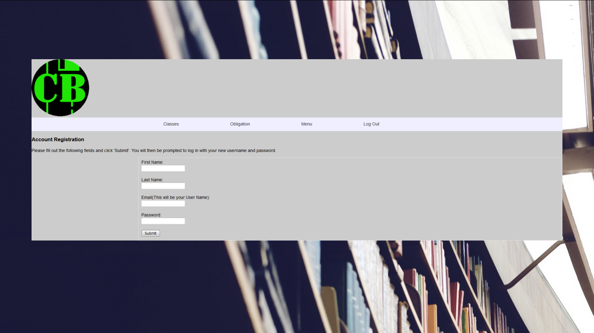

## Signing in for the First Time

Once you have entered your initial registration information, you will be forwarded back to the main page, and will be allowed to log in to the system using the credentials you just created. Enter your registration email address as your username and the password you chose into the boxes provided and click the “Log In” button to begin using the Class Bytes System.



# Dashboard Page

The dashboard page is the first page you will see upon logging in to the Class Bytes System. As a new user, all of the fields will be empty, because you haven’t entered any information yet. The dashboard page lists your current class schedule, all class obligations that are due on the current date, and all class obligations for the next day. Next to each of your classes, there is a button that will take you to the Class Detail Page, where you can see detailed information about the individual class. There is also an option in the Classes section to add a new class, and options in each of the assignments sections to add a new class obligation. In the ribbon at the top of the screen, several options are present in order to make navigation through the website easier. Clicking on the big “CB” logo will always bring you right back to the Dashboard page. This page is a bit boring right now – let’s add some classes to your schedule!

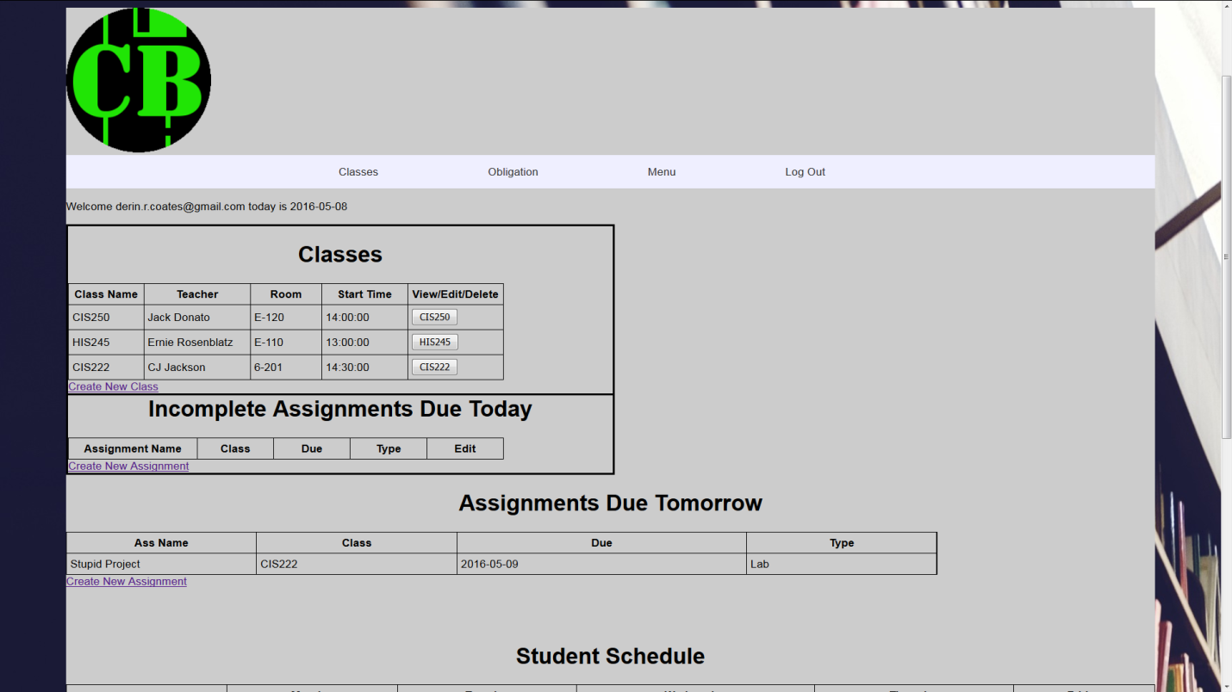

# Add New Class Page

Selecting “Add New Class” from the “Classes” dropdown on the main ribbon or clicking “Create New Class” from the Classes table will take you to the “Add New Class” page. You must enter your classes before you enter your instructors, class obligations, or class contacts. Here, you simply enter a name for your class (any name you want – we don’t judge), select the days that the class is held, and enter the start and end times for the class. You can also add any custom grade weighting scheme that your instructor may have given you, in order to be able to calculate your precise grades in the class. Alternatively, you can leave these fields blank, and we will assume simple averaging for you. Either way, you can always change it later if you wish. Clicking on the “Submit” button will save your class to your profile, and will allow you to enter another class if you choose. If you need to edit your class information, you can do so from the “Class Details” page. If you are done adding classes, then just click on the “Add New Instructor” dropdown on the “Instructors” portion of the main ribbon to add your instructors.

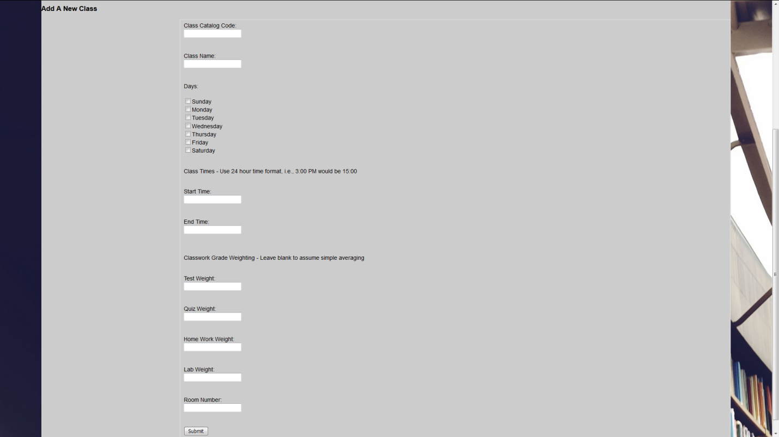

# Add New Instructor Page

Here is where you will be able to add the instructors for your classes. You can only enter instructors for classes that you have in your schedule. Simply enter the instructor’s name, select the class that they teach from the dropdown menu, and then add their phone number, office number, and email address. Clicking the “Submit” button will add that instructor to your account, and associate them with the class you chose. If no classes are listed in the dropdown box, you either need to add the class in the “Add New Class” page, or an instructor is already assigned to all of your classes. If you need to edit your instructor’s information, you can do so from the relevant “Class Detail” page.

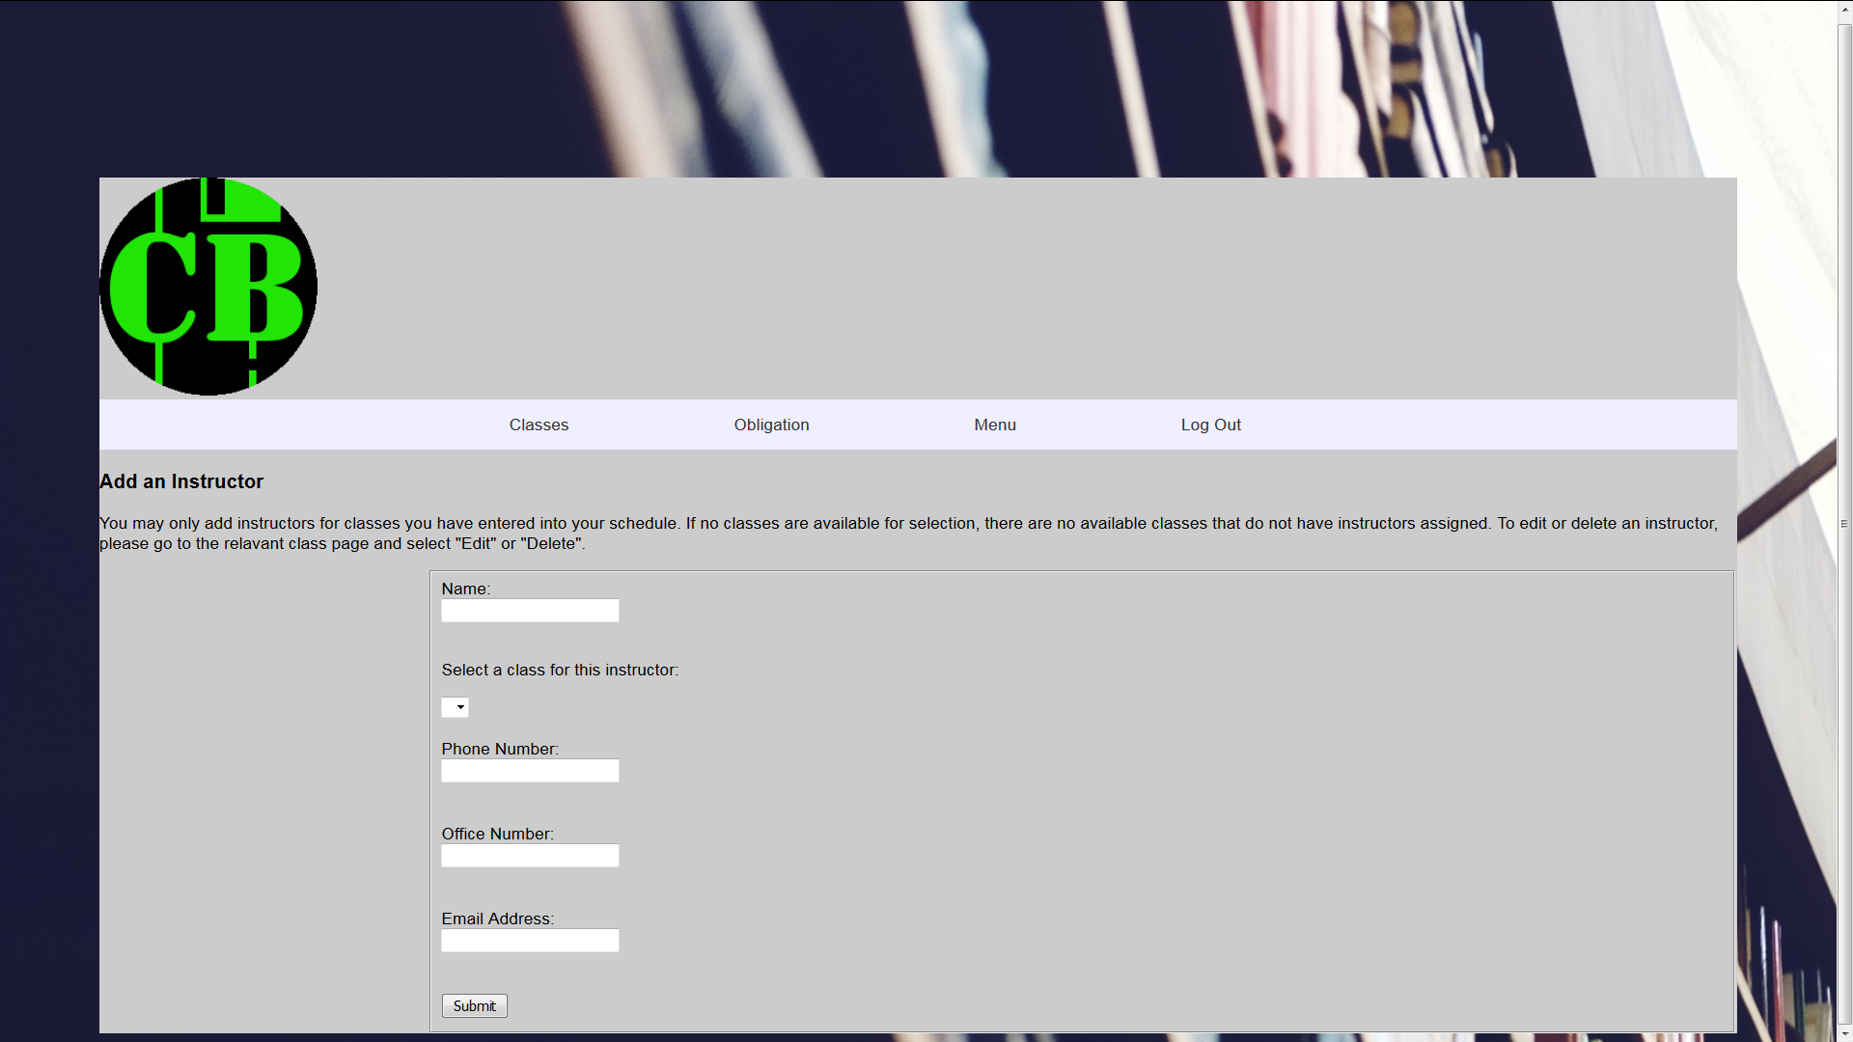

# Add New Obligation Page

Adding a new class obligation, such as an assignment, test, quiz, or lab, to your schedule is accomplished through the “Add New Obligation” page. You can navigate to the Add New Obligation page from either the “Add New Obligation” drop-down under the “Obligations” portion of the main navigation ribbon, or through the “Add New Obligation” links on the Dashboard page or the Class Detail pages. Simply enter a name for your class obligation, select the class it is for from the Class drop-down list, select the type of obligation from the Grade Type drop-down list, and enter a due date for the assignment. If the obligation you are entering is already completed, you can enter the grade here and mark it as completed as well. If not, the system will assume no current grade and that the obligation is not completed. You can edit these values when you complete your obligation using the “Edit” button on the Class Detail page. Class obligations will be shown on the Class Detail page, as well as the dashboard if they are overdue or due within 24 hours.

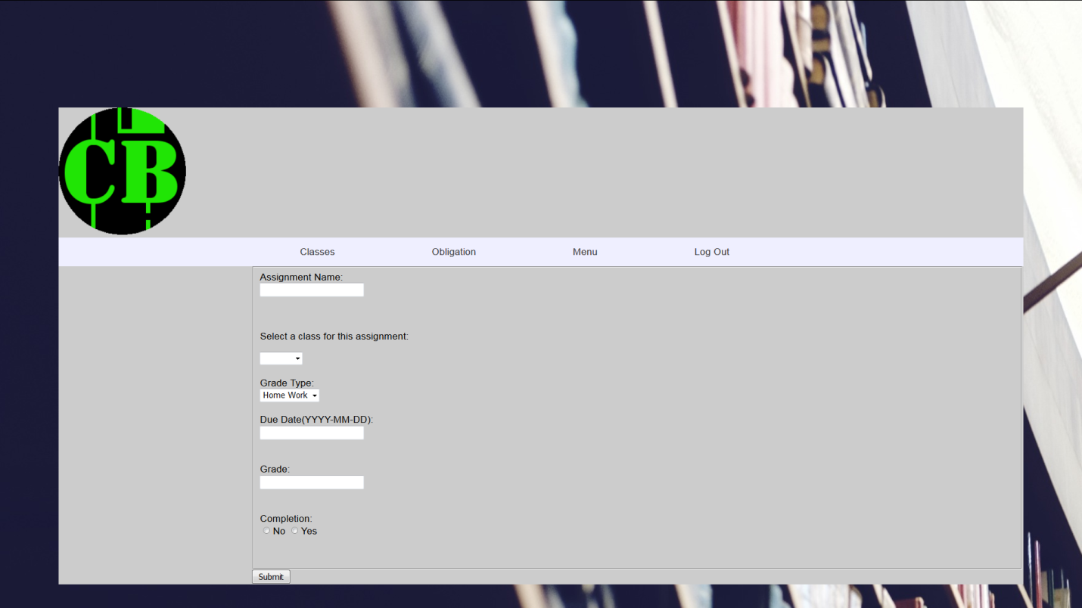

# Add New Student Contact Page

Here is where you will be able to add your student contacts for your classes. You can only enter student contacts for classes that you have in your schedule. Simply enter the student’s name, select the class that the contact is for from the dropdown menu, and then add their phone number and email address. Clicking the “Submit” button will add that student contact to your account, and associate them with the class you chose. If no classes are listed in the dropdown box, you will need to add the class in the “Add New Class” page. If you need to edit your student contact’s information, you can do so from the relevant “Class Detail” page.

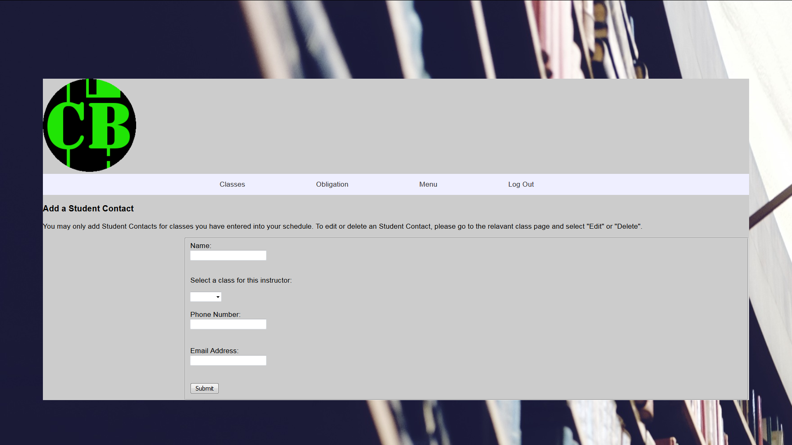

# Class Detail Page

The Class Detail page for a given class is accessed by clicking the button next to the class in the Dashboard page. The Class Detail page lists all of the class obligations for a particular class, both completed and not completed, along with their respective grades, and a cumulative grade for the class. Obligations that are incomplete and ungraded are not factored into the cumulative class average <<<make default grade *null* instead of 0 in the dB>>>. Alerts for obligations that are overdue or due within 24 hours are also displayed in the Class Detail page. The instructor information and list of student contacts for the particular class are also displayed. All obligations can be edited or graded by clicking the “Edit” button next to the obligation, or can be deleted by clicking the “Delete” button, instructor information can be edited by clicking “Edit Instructor” below their information, and class information can be edited by clicking “Edit Class” in the upper right-hand corner of the page. Student contact information can be edited by clicking the “Edit” button next to their name, or deleted by clicking the “Delete” button next to their name. Additionally, a class can be deleted by clicking “Delete Class” in the lower left-hand corner of the page, but be aware, deleting a class also deletes the obligations, student contacts, and instructor associated with that class as well.

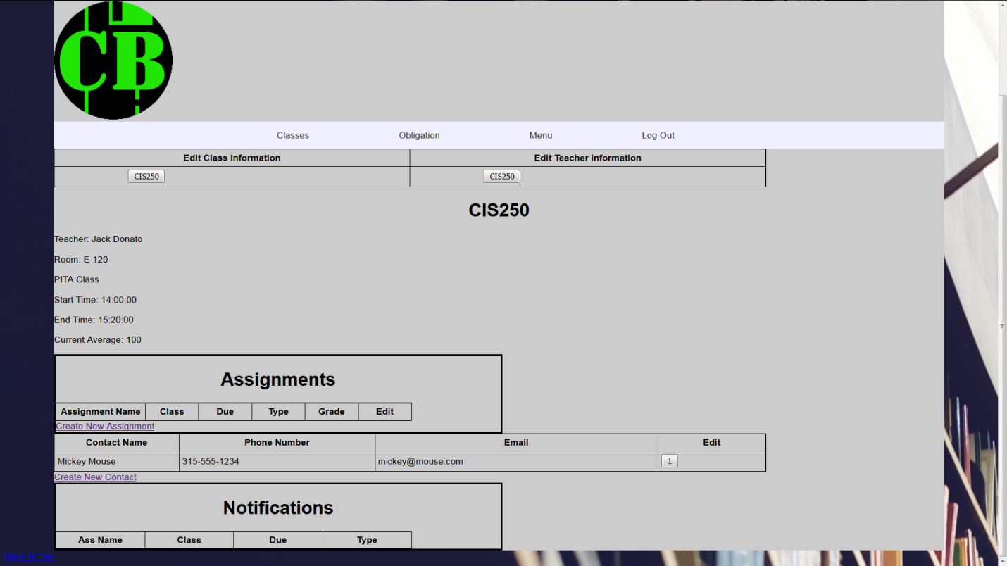

# Edit Class Page

The “Edit Class” page is accessed by clicking “Edit Class” in the upper right-hand corner of the Class Detail page. The Edit Class page is almost exactly like the Add New Class page, except the fields are filled in with the information you initially supplied. Edit whichever fields you need to, click the “Submit” button, and you class information for the chosen class will be updated in the system. Be aware, if you change or add a grade weighting scheme, your cumulative average grade on the Class Details page will change accordingly.

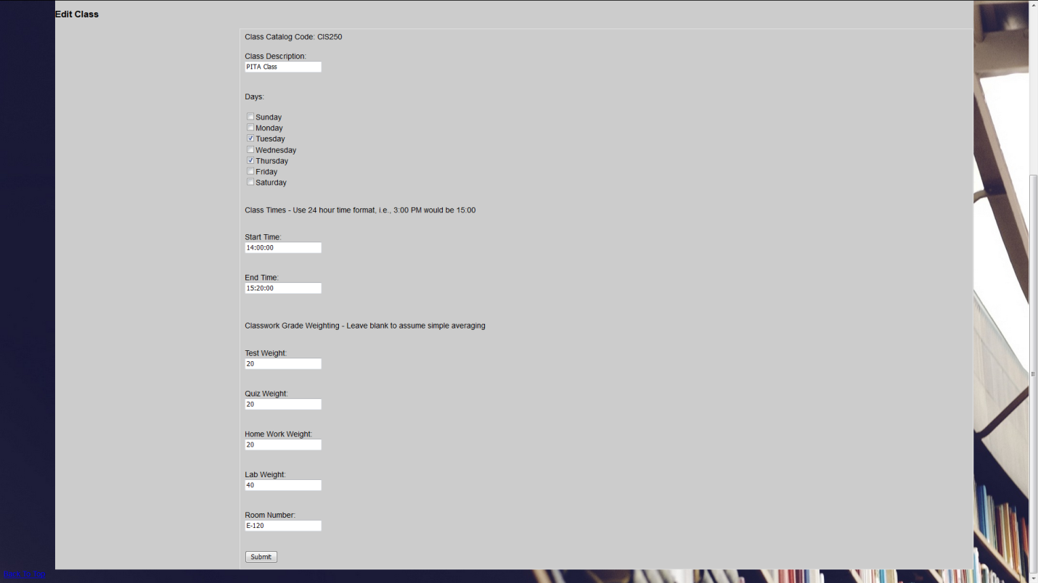

# Edit Instructor Information Page

The “Edit Instructor Information” page is accessed by clicking “Edit Instructor” below the instructor’s information on the Class Detail page. The Edit Instructor Information page is almost exactly like the Add New Instructor page, except the fields are filled in with the information you initially supplied. Edit whichever fields you need to, click the “Submit” button, and you instructor’s information for the chosen class will be updated in the system.

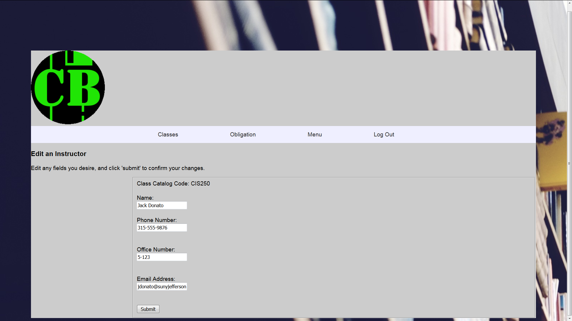

# Edit Obligations Page

The “Edit Obligations” page is accessed by clicking the “Edit” button next to the obligation on the Class Detail page. The Edit Obligations page is almost exactly like the Add New Obligation page, except the fields are filled in with the information you initially supplied. Edit whichever fields you need to, click the “Submit” button, and the information for the chosen obligation will be updated in the system. Common uses for this page include marking an obligation as completed, changing the due date for the obligation, or adding or changing a grade for the obligation.

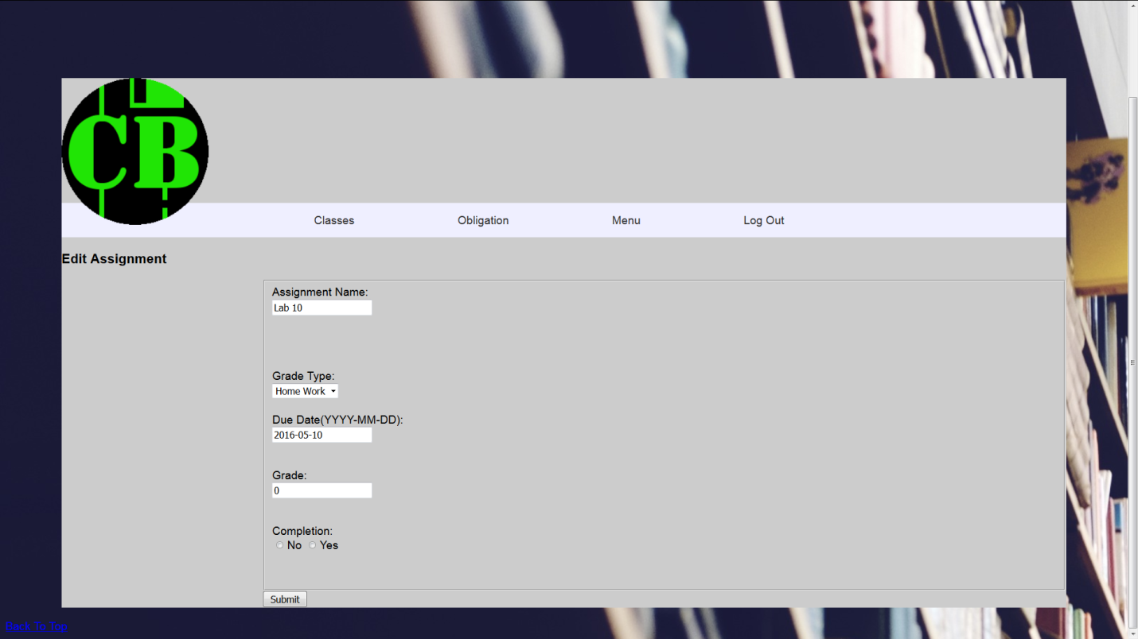

# Edit Student Contacts Page

The “Edit Student Contacts” page is accessed by by clicking the “Edit” button next to the name of the student contact on the Class Detail page. The Edit Student Contacts page is almost exactly like the Add New Student Contact page, except the fields are filled in with the information you initially supplied. Edit whichever fields you need to, click the “Submit” button, and the chosen student contact’s information for the chosen class will be updated in the system.

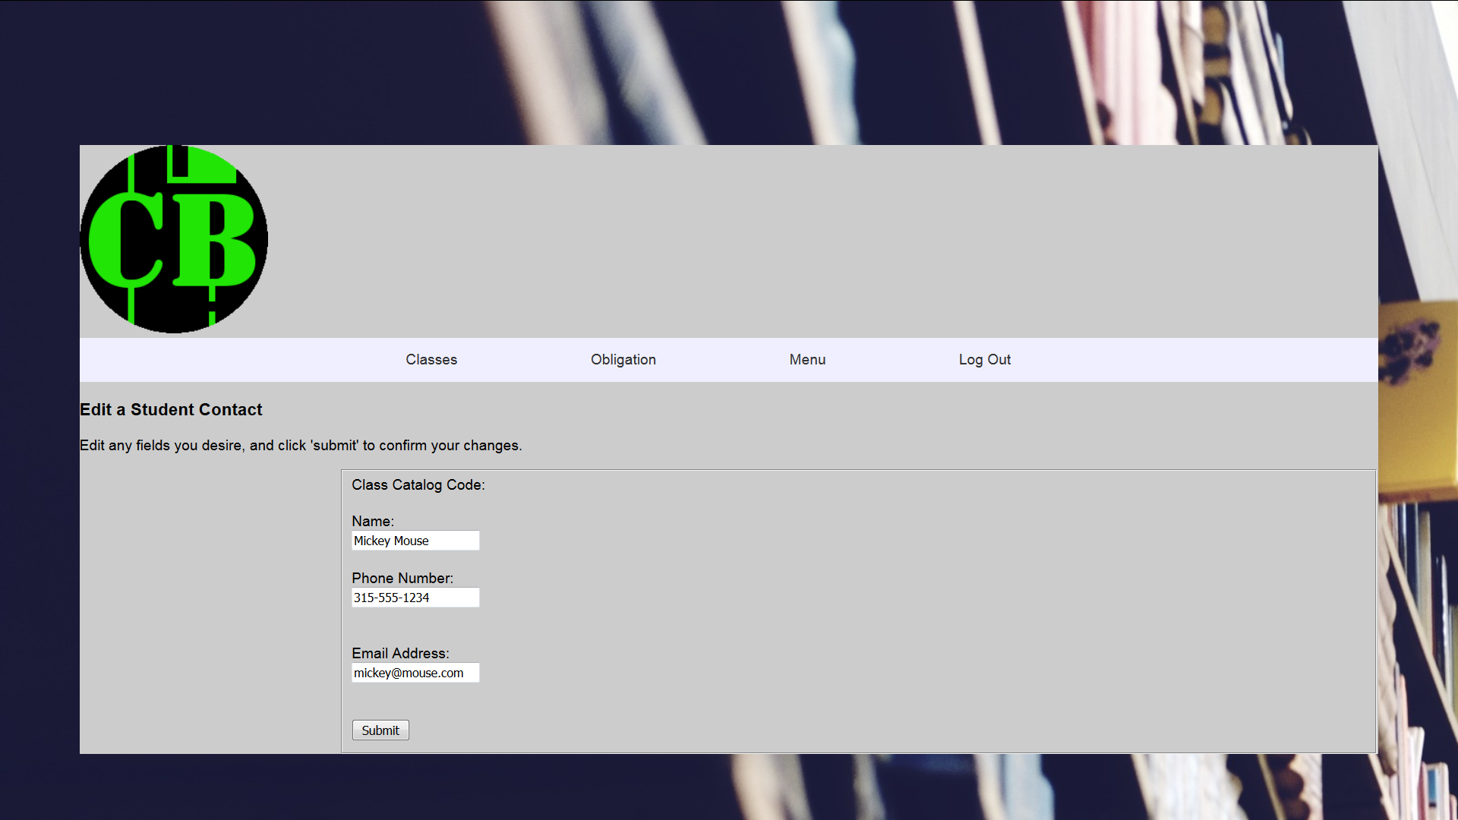

# Support

If you have any problems with the Class Bytes System, or have any questions, please feel free to contact us at (800) CLS-BYTS ((800) 257-2987) or by email at [support@classbytes.com](mailto:support@classbytes.com), and we will be happy to assist you.

Additionally, you may access our FAQ online at <http://192.188.202.2/cis222/College_Bytes/faq.html>.

Thanks for allowing us at College Bytes, LLC to serve your collegiate planning needs!